SALMON HOMECOMING CELEBRATION
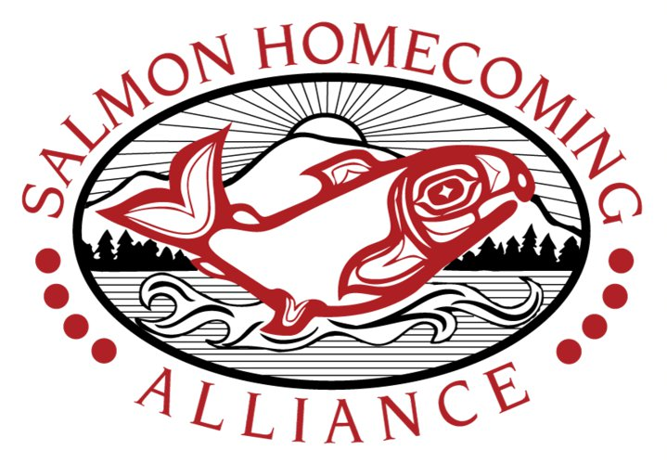

September 21-22, 2012
Waterfront Park – Downtown Seattle Central Waterfront

VENDOR APPLICATION
Application Deadline September 6, 2012

Business Name:
Contact Name:
Address:
City/State/Zip:
Phone Email
Tribal Affiliation:
Type of Vendor | 10 x 10 | 10 x 20
Arts & Crafts – New vendors must include photo/description of merchandise and booth. MUST provide your own tent/canopy. | $50 | $100
Community/Non-profit Organization  Information booths only. | $25 | NA
Corporate | $500 | $1,000
Food Booth  Please include a menu and photo of your booth. | N/A | $200

Directions: Please complete sections 1- 5 before submitting your application. Submitting an application does not guarantee booth placement in the Celebration. The Salmon Homecoming Committee will select applicants and notify accepted applicants by phone or email.
1. Booth Fee
Circle your booth fee on the chart above and enter the cost here ----------------------------→

2. Tables & Chairs
Specify the number of tables and chairs you would like at your booth
Tables (6 ft.): #__________ x $15 each
Chairs: #__________ x $3 each

3. Electricity
Check appropriate box if you need electricity at your booth.
Power availability not guaranteed and is dependant upon the location of your booth.
Food Booths only □ 20 amps/ $50
All other Booths □ 10 amps/ $25
4. Trade Show Fee  Government entities or businesses with City of Seattle Business Licenses are exempt from trade show fee. If you have a City of Seattle Business License, please provide your customer number here: __________________________ | $10.00  (unless exempt)
5. Total

SALMON HOMECOMING CELEBRATION 2012

Vendor Contract & Hold Harmless Agreement

THIS APPLICATION AND VENDOR AGREEMENT conveys the requirements for all vendors who will work at the Salmon Homecoming Celebration, September 21 - 22, 2012 at Waterfront Park, Seattle, WA. In return for use of space, you hereby agree to abide by all rules and regulations stipulated below.

Booth Space & Fees: Fees will be charged as indicated on the application page. Fees are used to cover the expenses of the Celebration. There are no refunds unless your application is denied during our review process or space is unavailable. No vendor will be assigned space or allowed to set up until full payment is received. For Arts & Crafts vendors, your booth must be designed to withstand wind and inclement weather. Booth locations are non-negotiable. PAYMENT IS DUE WHEN APPLICATION IS SUBMITTED.

Vendors must provide their own extension cords and lights. The extension cords must be 110 volt three-prong ground type as the Salmon Homecoming Alliance will not assume liability for inherent power hazards.

We are inviting traditional craftsman/demonstrators and environmentally friendly products. We therefore extend an invitation to all Native American participants who will continue to perpetuate the continuity of traditional Native American value systems. These craftsmen/vendors will be given priority in space assignment.
Craft vendors will refrain from selling plastic novelty items, carnival toys, foreign made "Indian Style" arts and crafts or mass produced textile goods (excluding local Indian design "T" or sweat shirts, or totes). Craft vendors will not sell tobacco products or food.
Roaming with the intent of promoting or selling merchandise is NOT allowed.
No alcoholic beverages, smoking, pets, loud music, or balloons allowed by vendors in the event site.
The Alliance reserves the right to remove any work it does not consider suitable for a general audience of adults and children.

SET UP TIMES: Friday, September 21, 2pm to 5:00pm and Saturday, September 22, 8am – 10am. Set in times will be confirmed with a confirmation letter to follow once you’ve been accepted. All vendors must be set up by 10 am, Saturday, September 22. You will be allowed to drive ONE VEHICLE onto the pier apron to unload and load. ALL VEHICLES MUST BE OFF THE PIER APRON BY 9:30 AM. Please note the Celebration is held on a pier structure this year with weight limits. Vehicles must be removed immediately after unloading. No vehicles will be allowed in the Park after 9:30am on 9/22. Violators will be towed at their own risk and expense. PLAN TO BRING YOUR OWN HAND TRUCKS, CARTS, etc. needed for loading and unloading. TAKE DOWN: Each party shall clean its area at the end of each day. Final clean up and breakdown shall be accomplished by 11 pm, Saturday, September 22. Vehicles will not be allowed on the apron or in the Park until the event is over and public participants have departed. All parties are required to supply their own garbage bags each day.

ALL GARBAGE MUST BE TAKEN TO THE DUMPSTER, NOT DUMPED IN THE TRASH CANS.

VENDORS FAILURE TO APPEAR, perform or otherwise substantially comply with the terms and conditions of this agreement shall result in the forfeit of their payment.

I/We the undersigned acknowledges they have read, understand, and agree to be bound by the terms of this agreement and for myself, my heirs, administrators and assigns, waive and release any and all right and claim for damaged I/we have against the Salmon Homecoming Alliance, City of Seattle or any organization or individual connected with this event, their representatives, successors and assigns for any and all damages, losses, thefts or injuries which I/we suffer while taking part in any activities linked to this event.

Signature Date

Print Name Business Name __

Make your check payable to Salmon Homecoming Alliance. Tel: 206-999-0532

Send both pages of completed application to: Salmon Homecoming Alliance 8329 NE 148th Pl Kenmore, WA 98028

Page 2 of 2

